**MAJOR PROJECT**

**ON**

**ONLINE WATCHES**

SUBMITTED IN PARTIAL FULFILLMENT OF THE REQUIREMENT FOR THE AWARD OF THE DEGREE

OF

**BACHELOR OF COMPUTER APPLICATIONS**

**Affiliated To: C.C.S. University, Meerut**

**Session : 2019-2022**

**Submitted To: Submitted By:**

**Mr. Shamshad Ali Shubham Gupta**

**(H.O.D.) Roll No.: 190904106053**

**BCA – VIth Sem.**



**MEWAR INSTITUTE OF MANAGEMENT,**

**SECTOR – 4C, VASUNDHARA, GHAZIABAD**

**CERTIFICATE**

This is to certify that **Shubham Gupta (190904106053)** a student of **Bachelor of Computer Application,** of **Mewar Institute of Management, Ghaziabad,** has undertaken the Summer Internship Project under my guidance for the Project Title **“Online Watches”** This Project Report is prepared in partial fulfilment for the Degree of Bachelor of Computer Application by C.C.S. University, Meerut.

To the best of my knowledge, this research work is original and no part of this report has been submitted by the student earlier to any other institution/ university.

**Mr. Shamshad Ali**

**(H.O.D.)**

**ACKNOWLEDGEMENT**

I would like to thank my major **Mr. Shamshad Ali (H.O.D.)** who persuaded and continuously guided me during the whole course of my project. I would also like to thank him for his insightful comments . I sincerely acknowledge and thank my family members and friends who gave me moral support from my childhood .

**SHUBHAM GUPTA**

**BCA – VIth Sem.**

INDEX

1. INTRODUCTION
   1. DEEFINATIONS
   2. OBJECTIVE
   3. Overall Description
2. INTRODUCTION TO TECHNOLOGY

2.1 About Web Technology

2.2 Introduction To HTML

2.3 Introduction To DHTML

2.4 Introduction To JS

2.5 Introduction To CSS

3 SCREENSHOT

3.1 HOME

3.2 PRODUCT

3.3 REGISTRATION

3.4 CONTACT US

3.5 FEEDBACK

4 CODING

3.1 HOME

3.2 PRODUCT

3.3 REGISTRATION

3.4 CONTACT US

3.5 FEEDBACK

5 CONCLUSION

6 REFERENCES

**INTRODUCTION**

In the modern age, the purpose of wearing a watch is no longer just about being able to tell the time. These days, as well as basic two-hand watches , watches have evolved to feature various sophisticated technologies which make life more convenient. As well as improvements in technology, watches are often considered a vital fashion accessory and are available, just like clothes, in all colours and styles to suit your taste, mood and environment. Watches have become so common place in modern day lifestyles, it is not uncommon for people to own several watches, just as they do with clothing outfits. Brands such as D&G, DKNY, and Calvin Klein produce some of the most fashionable watches in the world.  
  
Buying a [watch](http://www.watchshop.com/) can be an exciting experience. However it is difficult to choose only one watch from the huge range of watches available on the market. You may have preference to a particular brand, or maybe you need a specific feature for a sport. We hope this site provides sufficient information on our watches to help you make an informed decision.

**Definitions**

1. Shopping: This entails interaction between the customer and the shopkeeper dealing

withbuying,selling of commodities.

2. Product:An commodities that is being sold/given to a customer.

3. Customer:A buyer or probable buyer at the store.

4. Deal:A 2 way transaction usually money for goods.

**objective**

The objective of the project is to make an application in android

platform to purchase items in an existing shop. In order to build such an

application complete web support need to be provided. A complete and

efficient web application which can provide the online shopping

experience is the basic objective of the project

**Overall Description**

**Planned approach towards working:-**The working in the organization will be well planned and organized. The data will be stored properly in data stores which will help in retrieval of information as well as its storage.

**Accuracy: -** The level of accuracy in the proposed system will be higher. All operation would be done correctly and it ensures that whatever information is coming from the center is accurate.

**Reliability:** - The reliability of the proposed system will be high due to the above stated reasons. The reason for the increased reliability of the system is that now there would be proper storage of information.

**No Redundancy: -** In the proposed system utmost care would be that noitem is repeated anywhere, in storage or otherwise. This would assure economic use of storage space and consistency in the data stored.

**Immediate retrieval of information: -** The main objective of proposed system is to provide for a quick and efficient online food service. Any type of food would be available whenever the customer requires.

**Immediate storage of information: -** In manual system there are many problems to store the largest amount of information.

**Easy to Operate: -** The system should be easy to operate and should be such that it can be developed within a short period of time and fit in the limited budget of the use

**INTRODUCTION TO TECHNOLOGY**

ABOUT WEB TECHNOLOGY

Computers and other network devices need to communicate. A mechanism must make it possible for a computer to communicate with another computer on the same network or another network. The mechanism must ensure that a message moves from the sender to the recipient, enable the receiver to retrieve the message and send feedback, and acknowledge reception or failure of communication.  
According to [Microsoft - Official Home Page](http://microsoft.com/), some examples of web technologies include:  
1) Mark-up languages including HTML, CSS, XML, CGI and HTTP;  
2) Programming Languages and Technologies which help in creating applications for the web; some of the languages are Perl, C#, Java and Visual Basic .Net;  
3) Web servers and server technologies which facilitate request handling on a network where different users have to share the same resources and communicate with one another;  
4) Databases, which are crucial for data and information storage on a computer network; and  
5) Business applications customized for specific execution of tasks on a network.  
In short, web technology provides a platform for effective communication among different users and devices on a computer network.

INTRODUCTION TO HTML

What is HTML?

HTML is the standard markup language for creating Web pages.

* HTML stands for Hyper Text Markup Language
* HTML describes the structure of Web pages using markup
* HTML elements are the building blocks of HTML pages
* HTML elements are represented by tags
* HTML tags label pieces of content such as "heading", "paragraph", "table", and so on
* Browsers do not display the HTML tags, but use them to render the content of the page

HTML is a computer language devised to allow website creation. These websites can then be viewed by anyone else connected to the Internet. It is relatively **easy to learn**, with the basics being accessible to most people in one sitting; and quite **powerful** in what it allows you to create. It is constantly undergoing revision and evolution to meet the demands and requirements of the growing Internet audience under the direction of the [**» W3C**](http://www.w3.org/), the organisation charged with designing and maintaining the language.

The definition of HTML is **HyperText Markup Language**.

* *HyperText* is the method by which you move around on the web — by clicking on special text called **hyperlinks** which bring you to the next page. The fact that it is*hyper* just means it is not linear — i.e. you can go to any place on the Internet whenever you want by clicking on links — there is no set order to do things in.
* *Markup* is what **HTML tags** do to the text inside them. They mark it as a certain type of text (*italicised* text, for example).
* HTML is a *Language*, as it has code-words and syntax like any other language.

How does it work?

**HTML consists of a series of short**codes**typed into a text-file by the site author — these are the tags. The text is then**saved as a html file**, and**viewed through a [browser](http://www.yourhtmlsource.com/starthere/glossary.html#browser)**, like *Internet Explorer* or *Netscape Navigator*. This browser reads the file and translates the text into a visible form, hopefully rendering the page as the author had intended. Writing your own HTML entails using tags correctly to create your vision. You can use anything from a rudimentary text-editor to a powerful graphical editor to create HTML pages.**

**INTRODUCTION TO DHTML**

What is DHTML

DHTML stands for Dynamic HTML. The first thing that we need to clear about DHTML is that it is neither a language like HTML, JavaScript etc. nor a web standard. It is just a combination of HTML, JavaScript and CSS. It just uses these languages features to build dynamic web pages. DHTML is a feature of Netscape Communicator 4.0, and Microsoft Internet Explorer 4.0 and 5.0 and is entirely a "client-side"technology.

DHTML is differentiated from [Ajax](https://en.wikipedia.org/wiki/Ajax_(programming)) by the fact that a DHTML page is still request/reload-based. With DHTML, there may not be any interaction between the client and server after the page is loaded; all processing happens in JavaScript on the client side. By contrast, an Ajax page uses features of DHTML to initiate a request (or 'subrequest') to the server to perform additional actions. For example, if there are multiple tabs on a page, pure DHTML approach would load the contents of all tabs and then dynamically display only the one that is active, while AJAX could load each tab only if (and when) it is really needed.

**Features of DHTML**

1. Simplest feature is making the page dynamic.  
2. Can be used to create animations, games, applications, provide new ways of navigating   
3. DHTML use low-bandwidth effect which enhance web page functionality.  
4. Dynamic building of web pages is simple as no plug-in is required.  
5. Facilitates the usage of events, methods and properties and code reuse.

**INTRODUCTION TO JS**

In [computing](https://en.wikipedia.org/wiki/Computing), **JavaScript** is a [high-level](https://en.wikipedia.org/wiki/High-level_programming_language), [dynamic](https://en.wikipedia.org/wiki/Dynamic_programming_language), [untyped](https://en.wikipedia.org/wiki/Programming_language" \l "Type_system" \o "Programming language), and [interpreted](https://en.wikipedia.org/wiki/Interpreted_language) [programming language](https://en.wikipedia.org/wiki/Programming_language).[]](https://en.wikipedia.org/wiki/JavaScript#cite_note-FOOTNOTEFlanagan20111-6) It has been standardized in the [ECMAScript](https://en.wikipedia.org/wiki/ECMAScript" \o "ECMAScript) language specification. Alongside [HTML](https://en.wikipedia.org/wiki/HTML) and [CSS](https://en.wikipedia.org/wiki/CSS), JavaScript is one of the three core technologies of [World Wide Web](https://en.wikipedia.org/wiki/World_Wide_Web) [content production](https://en.wikipedia.org/wiki/Content_engineering); the majority of [websites](https://en.wikipedia.org/wiki/Website) employ it, and all modern [Web browsers](https://en.wikipedia.org/wiki/Web_browser) support it without the need for [plug-ins](https://en.wikipedia.org/wiki/Browser_extension). JavaScript is [prototype-based](https://en.wikipedia.org/wiki/Prototype-based_programming) with [first-class functions](https://en.wikipedia.org/wiki/First-class_function), making it a [multi-paradigm](https://en.wikipedia.org/wiki/Multi-paradigm) language, supporting [object-oriented](https://en.wikipedia.org/wiki/Object-oriented_programming), [imperative](https://en.wikipedia.org/wiki/Imperative_programming), and [functional](https://en.wikipedia.org/wiki/Functional_programming) [programming styles](https://en.wikipedia.org/wiki/Programming_paradigm). It has an [API](https://en.wikipedia.org/wiki/Application_programming_interface) for working with text, [arrays](https://en.wikipedia.org/wiki/Array_data_type), dates and [regular expressions](https://en.wikipedia.org/wiki/Regular_expression), but does not include any [I/O](https://en.wikipedia.org/wiki/Input/output), such as networking, storage, or graphics facilities, relying for these upon the host environment in which it is embedded.

Although there are strong outward similarities between JavaScript and Java, including language name, [syntax](https://en.wikipedia.org/wiki/Syntax_(programming_languages)), and respective [standard libraries](https://en.wikipedia.org/wiki/Standard_library), the two are distinct languages and differ greatly in their design. JavaScript was influenced by programming languages such as [Self](https://en.wikipedia.org/wiki/Self_(programming_language)) and [Scheme](https://en.wikipedia.org/wiki/Scheme_(programming_language)).

JavaScript is also used in environments that are not Web-based, such as [PDF](https://en.wikipedia.org/wiki/Portable_Document_Format) documents, [site-specific browsers](https://en.wikipedia.org/wiki/Site-specific_browser), and [desktop widgets](https://en.wikipedia.org/wiki/Desktop_widget). Newer and faster JavaScript [virtual machines](https://en.wikipedia.org/wiki/Virtual_machine) (VMs) and platforms built upon them have also increased the popularity of JavaScript for [server-side](https://en.wikipedia.org/wiki/Server-side) [Web applications](https://en.wikipedia.org/wiki/Web_application).

On the [client side](https://en.wikipedia.org/wiki/Client_side), developers have traditionally implemented JavaScript as an [interpreted](https://en.wikipedia.org/wiki/Interpreter_(computing)) language, but more recent browsers perform [just-in-time compilation](https://en.wikipedia.org/wiki/Just-in-time_compilation). Programmers also use JavaScript in [video-game development](https://en.wikipedia.org/wiki/Video_game_development), in crafting desktop and mobile applications, and in server-side [network programming](https://en.wikipedia.org/wiki/Computer_network_programming) with run-time environments such as [Node.js](https://en.wikipedia.org/wiki/Node.js).

JavaScript has become one of the most popular programming languages on the Web. Initially, however, many professional programmers denigrated the language because, among other reasons, its target audience consisted of Web authors and other such "amateurs". The advent of [Ajax](https://en.wikipedia.org/wiki/Ajax_(programming)) returned JavaScript to the spotlight and brought more professional programming attention. The result was a proliferation of comprehensive [frameworks and libraries](https://en.wikipedia.org/wiki/List_of_JavaScript_libraries), improved JavaScript programming practices, and increased usage of JavaScript outside Web browsers, as seen by the proliferation of [server-side JavaScript](https://en.wikipedia.org/wiki/Server-side_JavaScript) platforms.

In January 2009, the [CommonJS](https://en.wikipedia.org/wiki/CommonJS" \o "CommonJS) project was founded with the goal of specifying a common standard library mainly for JavaScript development outside the browser.

With the rise of [single-page applications](https://en.wikipedia.org/wiki/Single-page_application) and JavaScript-heavy sites, it is increasingly being used as a compile target for [source-to-source compilers](https://en.wikipedia.org/wiki/Source-to-source_compiler) from both [dynamic languages](https://en.wikipedia.org/wiki/Dynamic_typing)and [static languages](https://en.wikipedia.org/wiki/Static_typing).

**INTRODUCTION TO CSS**

**C**ascading **S**tyle **S**heets, fondly referred to as CSS, is a simple design language intended to simplify the process of making web pages presentable.

CSS handles the look and feel part of a web page. Using CSS, you can control the color of the text, the style of fonts, the spacing between paragraphs, how columns are sized and laid out, what background images or colors are used, layout designs,variations in display for different devices and screen sizes as well as a variety of other effects.

CSS is easy to learn and understand but it provides powerful control over the presentation of an HTML document. Most commonly, CSS is combined with the markup languages HTML or XHTML.

Advantages of CSS

* **CSS saves time** − You can write CSS once and then reuse same sheet in multiple HTML pages. You can define a style for each HTML element and apply it to as many Web pages as you want.
* **Pages load faster** − If you are using CSS, you do not need to write HTML tag attributes every time. Just write one CSS rule of a tag and apply it to all the occurrences of that tag. So less code means faster download times.
* **Easy maintenance** − To make a global change, simply change the style, and all elements in all the web pages will be updated automatically.
* **Superior styles to HTML** − CSS has a much wider array of attributes than HTML, so you can give a far better look to your HTML page in comparison to HTML attributes.
* **Multiple Device Compatibility** − Style sheets allow content to be optimized for more than one type of device. By using the same HTML document, different versions of a website can be presented for handheld devices such as PDAs and cell phones or for printing.
* **Global web standards** − Now HTML attributes are being deprecated and it is being recommended to use CSS. So its a good idea to start using CSS in all the HTML pages to make them compatible to future browsers.
* **Offline Browsing** − CSS can store web applications locally with the help of an offline catche.Using of this, we can view offline websites.The cache also ensures faster loading and better overall performance of the website.
* **Platform Independence** − The Script offer consistent platform independence and can support latest browsers as well.

Who Creates and Maintains CSS?

CSS was invited by **HåkonWium Lie** on October 10, 1994 and maintained through a group of people within the W3C called the CSS Working Group. The CSS Working Group creates documents called **specifications**. When a specification has been discussed and officially ratified by W3C members, it becomes a recommendation.

These ratified specifications are called recommendations because the W3C has no control over the actual implementation of the language. Independent companies and organizations create that software.

**NOTE** − The World Wide Web Consortium, or W3C is a group that makes recommendations about how the Internet works and how it should evolve.

CSS Versions

Cascading Style Sheets, level 1 (CSS1) was came out of W3C as a recommendation in December 1996. This version describes the CSS language as well as a simple visual formatting model for all the HTML tags.

CSS2 was became a W3C recommendation in May 1998 and builds on CSS1. This version adds support for media-specific style sheets e.g. printers and aural devices, downloadable fonts, element positioning and tables.

CSS3 was became a W3C recommendation in June 1999 and builds on older versions CSS. it has divided into documentations is called as Modules and here each module having new extension features defined in CSS2.

**FLOW CHART**

**FLOW CHART**

Execution of Clock Management System

Print “Press 1 For Timer” Print ”Press 2 For Date” Print “Press 3 For Stopwatch” Print “Press 4 For Digital Clock”

is i >=0

i = x

Case 1

Yes No

i = i - 1

Input x

is i<=32000

Case 2

Yes

(delay)

Print Stop, Time is over

i =2013

i = i + 1

No

j==2 && i%4=10

i%4==0 && j==2

Yes

j=4 or 6 or 9 or 11

Yes No No

is j <=12

j = 1

No

j=j+1

Yes Yes Yes

x=29

x=30

x=28

k=1

is k<=x

k=k+1

x=31

No

Yes

Case 3

is i<=32400

i=1

Print k, j, i

Yes

i=i+1

(delay)

Yes

Clear Screen every time when loop is executing by (clrscr)

(delay)

Positioning the stopwatch with the help of (gotoxy)

Case 4

Print i

Yes

Get time from system using (gettime)

No

while(!kbhit)

Print time

do

Positioning the clock at which time to be displayed using (gotoxy)

**DATAFLOW DIAGRAM**

**DATAFLOW DIAGRAM**

**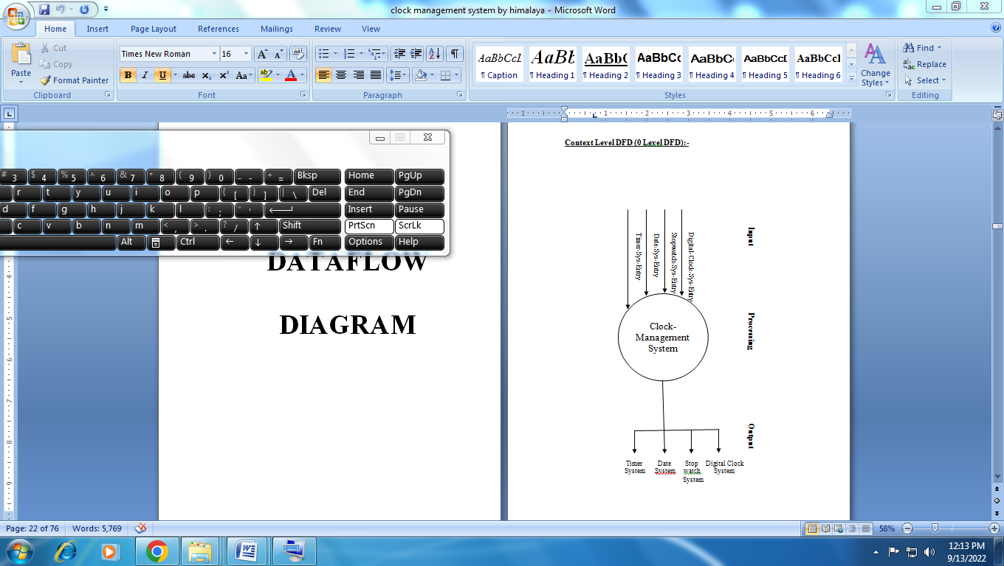**

**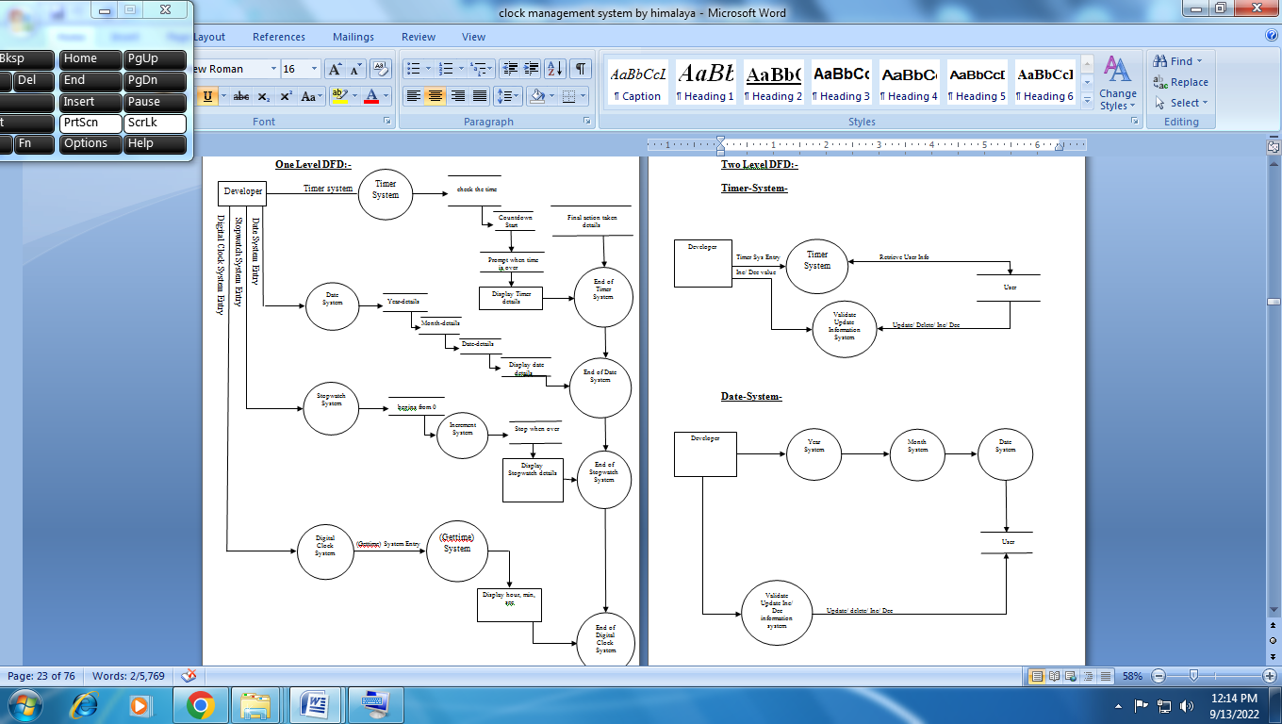**

**Two Level DFD:-**

**Timer-System-**

Developer

Developer

Timer Sys Entry Retrieve User Info

Inc/ Dec value

Update/ Delete/ Inc/ Dec User

**Date-System-**

User

Update/ delete/ Inc/ Dec

**Stopwatch-System-**

Developer

Developer

Begins from 0 Check User Command

Inc/ Dec

User

**Digital-Clock-System-**

Hour, min, sec

**ER- DIAGRAM**

ER - Diagram

Clock management system

execute

Analog clock

Case 2

Date

case 1

Timer

Case 3

Stopwatch

Case 4

Digital clock

Screenshot

Home

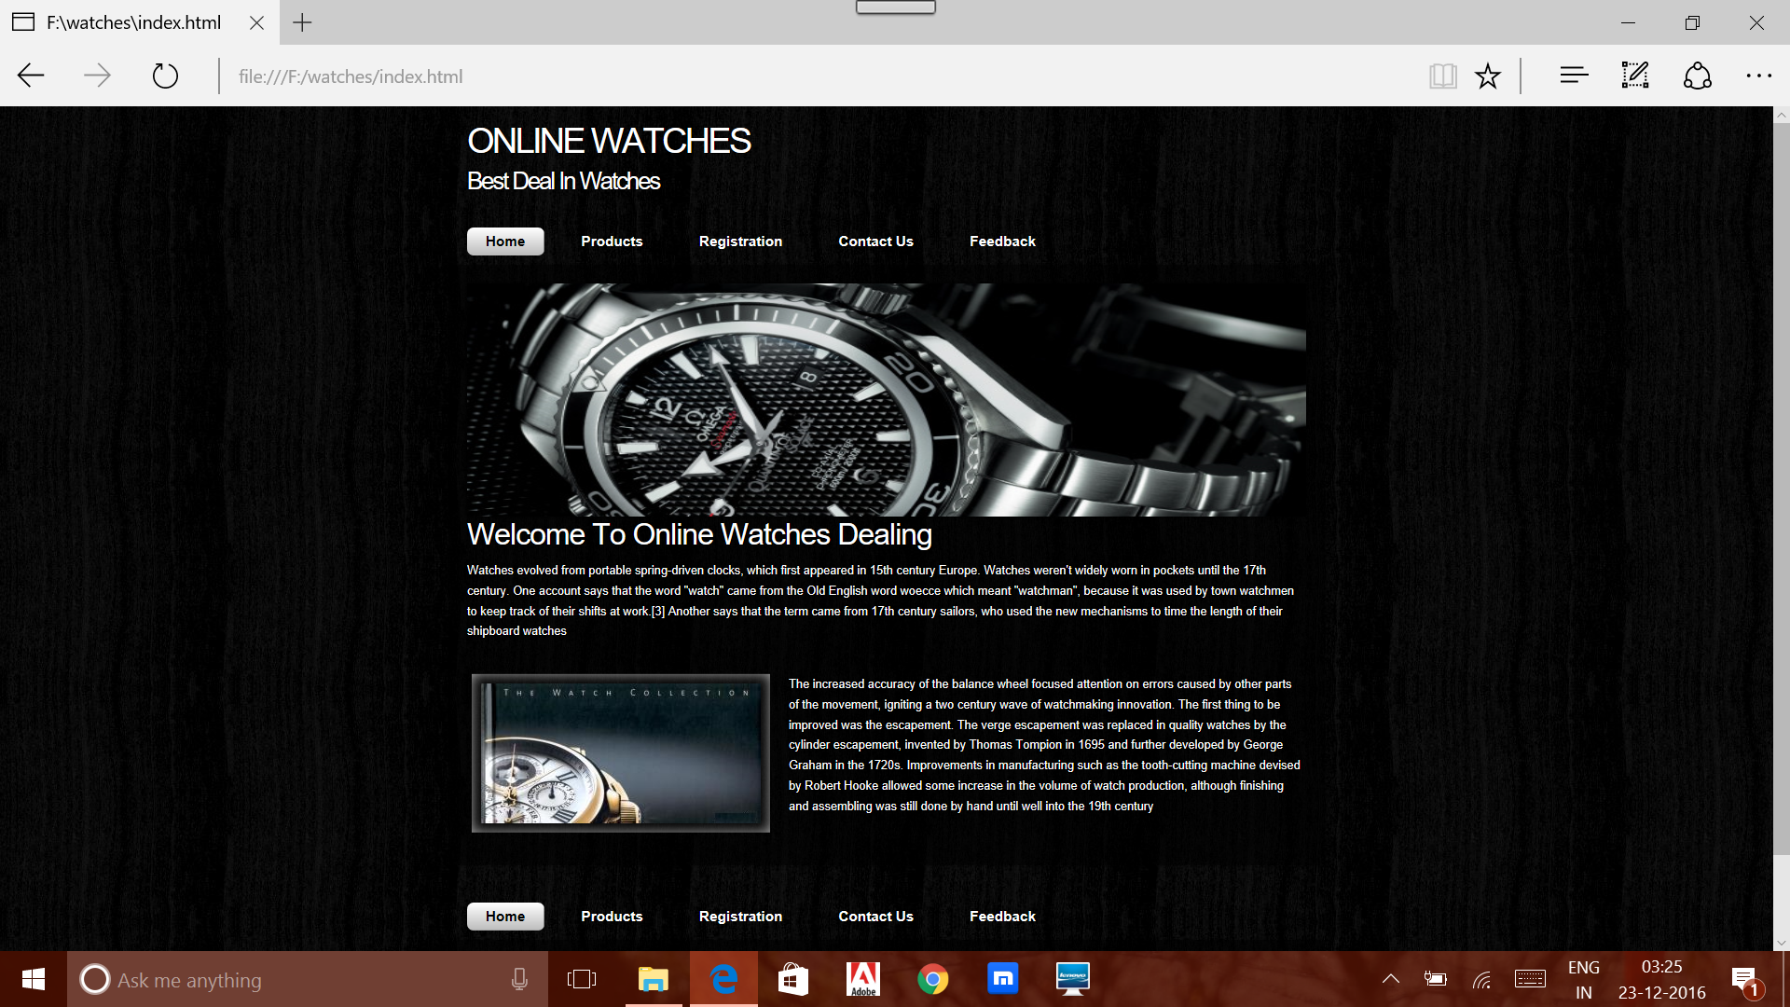

Product

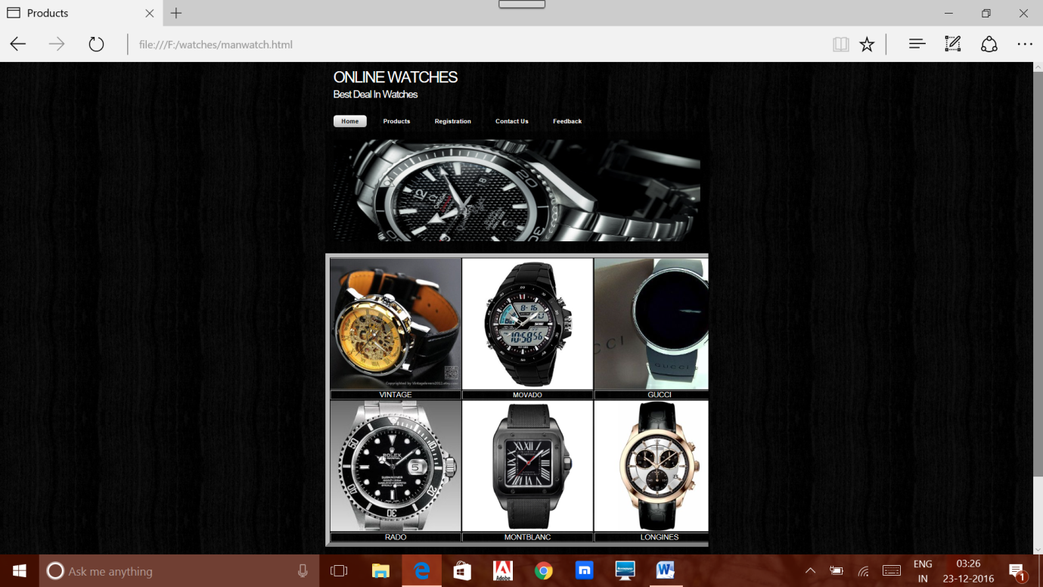

Registration

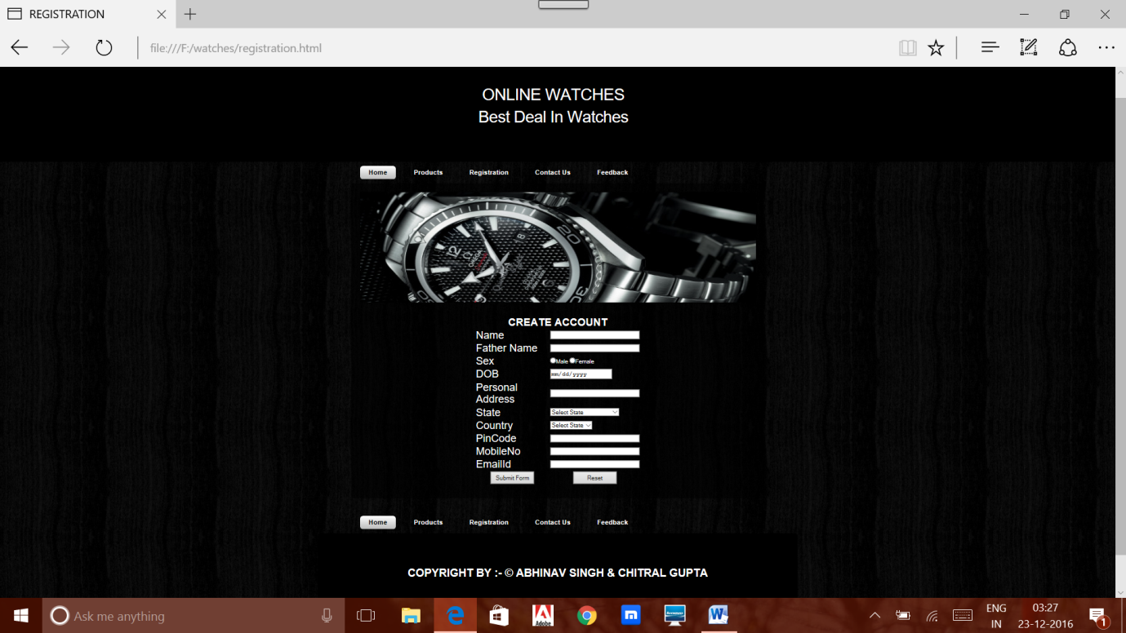

Contact us

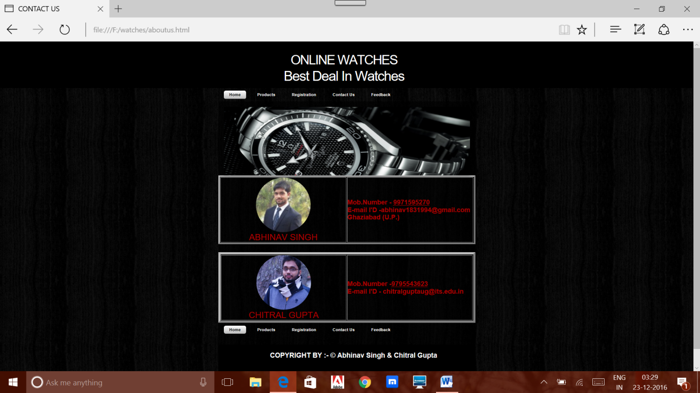

Feedback

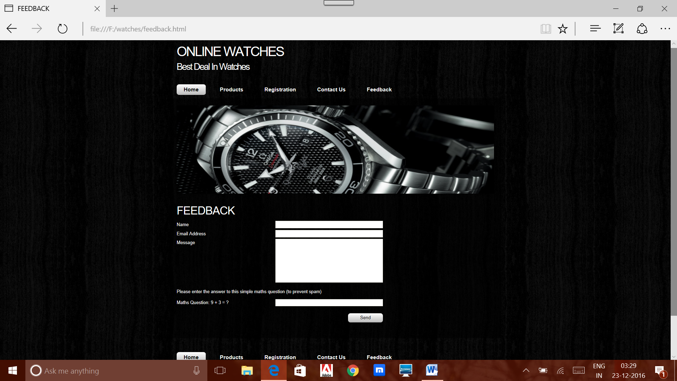

**CODING**

**Home**

<html>

<head>

<meta name="description" content="website description" />

<meta name="keywords" content="website keywords, website keywords" />

<meta http-equiv="content-type" content="text/html; charset=windows-1252" />

<link rel="stylesheet" type="text/css" href="css/style.css" />

<!--modernizr enables HTML5 elements and feature detects -->

<script type="text/javascript" src="js/modernizr-1.5.min.js"></script>

</head>

<body>

<div id="main">

<header>

<div id="banner">

<div id="welcome">

<h3>ONLINE WATCHES </h3>

</div><!--close welcome-->

<div id="welcome\_slogan">

<h3>Best Deal In Watches</h3>

</div><!--close welcome\_slogan-->

</div><!--close banner-->

</header>

<nav>

<div id="menubar">

<ul id="nav">

<li class="current"><a href="index.html">Home</a></li>

<li><a href="manwatch.html">Products</a></li>

<li><a href="registration.html">Registration</a></li>

<li><a href="aboutus.html">Contact Us</a></li>

<li><a href="feedback.html">Feedback</a></li>

</ul>

</div><!--close menubar-->

</nav>

<div id="site\_content">

<div class="slideshow">

<ul class="slideshow">

<li class="show"><img width="900" height="250" src="images/bond.jpg" alt="&quot;Enter your caption here&quot;" /></li>

<li><img width="900" height="250" src="images/best.jpg" alt="&quot;Enter your caption here&quot;" /></li>

</ul>

</div>

<div id="content">

<div class="content\_item">

<h1>Welcome To Online Watches Dealing</h1>

<p>Watches evolved from portable spring-driven clocks, which first appeared in 15th century Europe. Watches weren't widely worn in pockets until the 17th century. One account says that the word "watch" came from the Old English word woecce which meant "watchman", because it was used by town watchmen to keep track of their shifts at work.[3] Another says that the term came from 17th century sailors, who used the new mechanisms to time the length of their shipboard watches</p>

<div class="content\_imagetext">

<div class="content\_image">

<imgsrc="images/mont.jpg" alt="image1"/>

</div>

<p>The increased accuracy of the balance wheel focused attention on errors caused by other parts of the movement, igniting a two century wave of watchmaking innovation. The first thing to be improved was the escapement. The verge escapement was replaced in quality watches by the cylinder escapement, invented by Thomas Tompion in 1695 and further developed by George Graham in the 1720s. Improvements in manufacturing such as the tooth-cutting machine devised by Robert Hooke allowed some increase in the volume of watch production, although finishing and assembling was still done by hand until well into the 19th century </p>

</div><!--close content\_imagetext-->

</div><!--close content\_item-->

</div><!--close content-->

</div><!--close site\_content-->

</div><!--close main-->

<nav>

<div id="menubar">

<ul id="nav">

<li class="current"><a href="index.html">Home</a></li>

<li><a href="manwatch.html">Products</a></li>

<li><a href="registration.html">Registration</a></li>

<li><a href="aboutus.html">Contact Us</a></li>

<li><a href="feedback.html">Feedback</a></li>

</ul>

</div><!--close menubar-->

</nav>

<footer>COPYRIGHT BY :- &copy; ABHINAV SINGH & CHITRAL GUPTA </footer>

<!--javascript at the bottom for fast page loading -->

<script type="text/javascript" src="js/jquery.js"></script>

<script type="text/javascript" src="js/image\_slide.js"></script>

</body>

</html>

**Product**

<html>

<head>

<title>Products</title>

<meta name="description" content="website description" />

<meta name="keywords" content="website keywords, website keywords" />

<meta http-equiv="content-type" content="text/html; charset=windows-1252" />

<link rel="stylesheet" type="text/css" href="css/style.css" />

<!--modernizr enables HTML5 elements and feature detects -->

<script type="text/javascript" src="js/modernizr-1.5.min.js"></script>

</head>

<body>

<div id="main">

<header>

<div id="banner">

<div id="welcome">

<h3>ONLINE WATCHES </h3>

</div><!--close welcome-->

<div id="welcome\_slogan">

<h3>Best Deal In Watches</h3>

</div><!--close welcome\_slogan-->

</div><!--close banner-->

</header>

<nav>

<div id="menubar">

<ul id="nav">

<li class="current"><a href="index.html">Home</a></li>

<li><a href="manwatch.html">Products</a></li>

<li><a href="registration.html">Registration</a></li>

<li><a href="aboutus.html">Contact Us</a></li>

<li><a href="feedback.html">Feedback</a></li>

</ul>

</div><!--close menubar-->

</nav>

<div id="site\_content">

<div class="slideshow">

<ul class="slideshow">

<li class="show"><img width="900" height="250" src="images/bond.jpg" alt="&quot;Enter your caption here&quot;" /></li>

<li><img width="900" height="250" src="images/best.jpg" alt="&quot;Enter your caption here&quot;" /></li>

</ul>

</div>

<br>

<br>

<table border="10" align="center">

<tr>

<td><a href="vintage.html"><imgsrc="images\m1.jpg"></td>

<td><a href="movado.html"><imgsrc="images\m2.jpg"></td>

<td><a href="gucci.html"><imgsrc="images\m3.jpg"></td>

</tr>

<tr><td><font size="4" color="white"><center>VINTAGE</td>

<td><font size="" color="white"><center>MOVADO</td>

<td><font size="4" color="white"><center>GUCCI</td></tr>

<tr>

<td><a href="rado.html"><imgsrc="images\m4.jpg"></td>

<td><a href="Montblanc.html"><imgsrc="images\m5.jpg"></td>

<td><a href="Longines.html"><imgsrc="images\m6.jpg"></td>

</tr>

<tr><td><font size="4" color="white"><center>RADO</td>

<td><font size="4" color="white"><center>MONTBLANC</td><td>

<font size="4" color="white"><center>LONGINES</td></tr>

</table>

<br>

<br>

<nav>

<div id="menubar">

<ul id="nav">

<li class="current"><a href="index.html">Home</a></li>

<li><a href="manwatch.html">Products</a></li>

<li><a href="registration.html">Registration</a></li>

<li><a href="aboutus.html">Contact Us</a></li>

<li><a href="feedback.html">Feedback</a></li>

</ul>

</div><!--close menubar-->

</nav>

<footer>COPYRIGHT BY :- &copy; ABHINAV SINGH & CHITRAL GUPTA </footer>

<!--javascript at the bottom for fast page loading -->

<script type="text/javascript" src="js/jquery.js"></script>

<script type="text/javascript" src="js/image\_slide.js"></script>

</body>

</html>

**Product vintage**

<!DOCTYPE html>

<html>

<head>

<title>FEEDBACK</title>

<meta name="description" content="website description" />

<meta name="keywords" content="website keywords, website keywords" />

<meta http-equiv="content-type" content="text/html; charset=windows-1252" />

<link rel="stylesheet" type="text/css" href="css/style.css" />

<!--modernizr enables HTML5 elements and feature detects -->

<script type="text/javascript" src="js/modernizr-1.5.min.js"></script>

</head>

<body>

<div id="main">

<header>

<div id="banner">

<div id="welcome">

<h3>ONLINE WATCHES </h3>

</div><!--close welcome-->

<div id="welcome\_slogan">

<h3>Best Deal In Watches</h3>

</div><!--close welcome\_slogan-->

</div><!--close banner-->

</header>

<nav>

<div id="menubar">

<ul id="nav">

<li class="current"><a href="index.html">Home</a></li>

<li><a href="manwatch.html">Products</a></li>

<li><a href="registration.html">Registration</a></li>

<li><a href="aboutus.html">Contact Us</a></li>

<li><a href="feedback.html">Feedback</a></li>

</ul>

</div><!--close menubar-->

</nav>

<div id="site\_content">

<div class="slideshow">

<ul class="slideshow">

<li class="show"><img width="900" height="250" src="images/bond.jpg" alt="&quot;Enter your caption here&quot;" /></li>

<li><img width="900" height="250" src="images/best.jpg" alt="&quot;Enter your caption here&quot;" /></li>

</ul>

</div>

<div id="content">

<div class="content\_item">

<div class="form\_settings">

<br>

<h1>FEEDBACK</h1>

<p><span>Name</span><input class="contact" type="text" name="your\_name" value="" /></p>

<p><span>Email Address</span><input class="contact" type="text" name="your\_email" value="" /></p>

<p><span>Message</span><textarea class="contact textarea" rows="8" cols="50" name="your\_message"></textarea></p>

<p style="padding: 10px 0 10px 0;">Please enter the answer to this simple maths question (to prevent spam)</p>

<p><span>Maths Question: 9 + 3 = ?</span><input type="text" name="user\_answer" class="contact" /><input type="hidden" name="answer" value="4d76fe9775" /></p>

<p style="padding-top: 15px"><span>&nbsp;</span><input class="submit" type="submit" name="contact\_submitted" value="Send" /></p>

</div><!--close form\_settings-->

</div><!--close content\_item-->

</div><!--close content-->

</div><!--close site\_content-->

</div><!--close main-->

<nav>

<div id="menubar">

<ul id="nav">

<li class="current"><a href="index.html">Home</a></li>

<li><a href="manwatch.html">Products</a></li>

<li><a href="registration.html">Registration</a></li>

<li><a href="aboutus.html">Contact Us</a></li>

<li><a href="feedback.html">Feedback</a></li>

</ul>

</div><!--close menubar-->

</nav>

<footer>COPYRIGHT BY :- &copy; ABHINAV SINGH & CHITRAL GUPTA </footer>

<!--javascript at the bottom for fast page loading -->

<script type="text/javascript" src="js/jquery.js"></script>

<script type="text/javascript" src="js/image\_slide.js"></script>

</body>

</html

**Registration**

<!DOCTYPE html>

<html>

<head>

<title>REGISTRATION</title>

<meta name="description" content="website description" />

<meta name="keywords" content="website keywords, website keywords" />

<meta http-equiv="content-type" content="text/html; charset=windows-1252" />

<link rel="stylesheet" type="text/css" href="css/style.css" />

<!--modernizr enables HTML5 elements and feature detects -->

<script type="text/javascript" src="js/modernizr-1.5.min.js"></script>

</head>

<body>

<style>

header, footer

{

padding: 3em;

font-size:25px;

color: white;

background-color: black;

clear: left;

text-align:center;

}

</style>

<div id="main">

<header>

<div id="banner">

<div id="welcome">

<h4>ONLINE WATCHES </h4>

</div><!--close welcome-->

<div id="welcome\_slogan">

<h4>Best Deal In Watches</h4>

</div><!--close welcome\_slogan-->

</div><!--close banner-->

</header>

<nav>

<div id="menubar">

<ul id="nav">

<li class="current"><a href="index.html">Home</a></li>

<li><a href="manwatch.html">Products</a></li>

<li><a href="registration.html">Registration</a></li>

<li><a href="aboutus.html">Contact Us</a></li>

<li><a href="feedback.html">Feedback</a></li>

</ul>

</div><!--close menubar-->

</nav>

<div id="site\_content">

<div class="slideshow">

<ul class="slideshow">

<li class="show"><img width="900" height="250" src="images/bond.jpg" alt="&quot;Enter your caption here&quot;" /></li>

<li><img width="900" height="250" src="images/home\_2.jpg" alt="&quot;Enter your caption here&quot;" /></li>

</ul>

</div>

<br><br>

<form action="#" name="createaccount" onsubmit="return(validate());">

<table cellpadding="2" width="40%" height="100%" background="image\b12.jpg" border="0" align="center"

cellspacing="2" >

<tr>

<td colspan=2>

<center><font size=5><b> CREATE ACCOUNT </b></font></center>

</td>

</tr>

<tr>

<td><font size=5>Name</td>

<td><input type="text" name=textnames id="textname" size="30"></td>

</tr>

<tr>

<td><font size=5>Father Name</td>

<td><input type="text" name="fathername" id="fathername"

size="30"></td>

</tr>

<tr>

<td><font size=5>Sex</td>

<td><input type="radio" name="sex" value="male" size="10">Male

<input type="radio" name="sex" value="Female" size="10">Female</td>

</tr>

<tr>

<td><font size=5>DOB</td>

<td><input type="date" name="dob" id="dob" size="30"></td>

</tr>

<tr>

<td><font size=5>Personal Address</td>

<td><input type="text" name="personaladdress"

id="personaladdress" size="30"></td>

</tr>

<tr>

<td><font size=5>State</td>

<td><select Name="State">

<option value="-1" selected>Select State</option>

<option value="Andhra Pradesh">Andhra Pradesh</option>

<option value="Arunachal Pradesh">Arunachal Pradesh</option>

<option value="Assam">Assam</option>

<option value="Andaman and Nicobar">Andaman and Nicobar</option>

<option value="Bihar">Bihar</option>

<option value="Chandigarh">Chandigarh</option>

<option value="Chattisgarh">Chattisgarh</option>

<option value="Dadra And Nagar">Dadra And Nagar</option>

<option value="Daman and Diu">Daman and Diu</option>

<option value="Delhi">Delhi</option>

<option value="Goa">Goa</option>

<option value="Gujarat">Gujarat</option>

<option value="Haryana">Haryana</option>

<option value="Himachal Pradesh">Himachal Pradesh</option>

<option value="Jammu and Kashmir">Jammu and Kashmir</option>

<option value="Jharkhand">Jharkhand</option>

<option value="Karnataka">Karnataka</option>

<option value="Kerala">Kerala</option>

<option value="Lakshadweep">Lakshadweep</option>

<option value="Madhya Pradesh">Madhya Pradesh</option>

<option value="Maharashtra">Maharashtra</option>

<option value="Manipur">Manipur</option>

<option value="Meghalaya">Meghalaya</option>

<option value="Mizoram">Mizoram</option>

<option value="Nagaland">Nagaland</option>

<option value="Orissa">Orissa</option>

<option value="Pondicherry">Pondicherry</option>

<option value="Punjab">Punjab</option>

<option value="Rajasthan">Rajasthan</option>

<option value="Sikkim">Sikkim</option>

<option value="Tamil Nadu">Tamil Nadu</option>

<option value="Tripura">Tripura</option>

<option value="Uttaranchal">Uttaranchal</option>

<option value="Uttar Pradesh">Uttar Pradesh</option>

<option value="West Bengal">West Bengal</option>

<option value="OTHERS">Others</option>

</select>

</td>

</tr>

<tr>

<td><font size=5>Country</td>

<td><select Name="Country">

<option value="select">Select State</option>

<option value="Andhra Pradesh">INDIA</option>

<option value="Arunachal Pradesh">OTHERS</option>

<tr>

<td><font size=5>PinCode</td>

<td><input type="text" name="pincode" id="pincode" size="30"></td>

</tr>

<tr>

<td><font size=5>MobileNo</td>

<td><input type="text" name="mobileno" id="mobileno" size="30"></td>

</tr>

<tr>

<td><font size=5>EmailId</td>

<td><input type="email" name="emailid" id="emailid" size="30"></td>

</tr>

<tr>

<td><center><input type="submit" value="Submit Form" style="height:30px; width:100px"></td>

<td><center><input type="reset" style="height:30px; width:100px"></td>

</tr>

</table>

<br>

<br>

</form>

</div><!--close content-->

</div><!--close site\_content-->

</div><!--close main-->

<nav>

<div id="menubar">

<ul id="nav">

<li class="current"><a href="index.html">Home</a></li>

<li><a href="manwatch.html">Products</a></li>

<li><a href="registration.html">Registration</a></li>

<li><a href="aboutus.html">Contact Us</a></li>

<li><a href="feedback.html">Feedback</a></li>

</ul>

</div><!--close menubar-->

</nav>

<footer>COPYRIGHT BY :- &copy; ABHINAV SINGH & CHITRAL GUPTA </footer>

<!--javascript at the bottom for fast page loading -->

<script type="text/javascript" src="js/jquery.js"></script>

<script type="text/javascript" src="js/image\_slide.js"></script>

</body>

</html>

**Contact us**

<html>

<head>

<style>

.round {

border-radius: 100%;

overflow: hidden;

width: 200px;

height: 200px;

}

.round img {

display: block;

/\* Stretch

height: 130%;

width: 100%; \*/

min-width: 100%;

min-height: 130%;

}

</style>

</head>

<body>

<title>CONTACT US</title>

<meta name="description" content="website description" />

<meta name="keywords" content="website keywords, website keywords" />

<meta http-equiv="content-type" content="text/html; charset=windows-1252" />

<link rel="stylesheet" type="text/css" href="css/style.css" />

<!--modernizr enables HTML5 elements and feature detects -->

<script type="text/javascript" src="js/modernizr-1.5.min.js"></script>

</head>

<body>

<div id="main">

<header>

<div id="banner">

<div id="welcome">

<h3><font size="130%">ONLINE WATCHES </font></h3>

</div><!--close welcome-->

<br><br>

<div id="welcome\_slogan">

<h3>Best Deal In Watches</h3>

</div><!--close welcome\_slogan-->

</div><!--close banner-->

</header>

<nav>

<div id="menubar">

<ul id="nav">

<li class="current"><a href="index.html">Home</a></li>

<li><a href="manwatch.html">Products</a></li>

<li><a href="registration.html">Registration</a></li>

<li><a href="aboutus.html">Contact Us</a></li>

<li><a href="feedback.html">Feedback</a></li>

</ul>

</div><!--close menubar-->

</nav>

<div id="site\_content">

<div class="slideshow">

<ul class="slideshow">

<li class="show"><img width="900" height="250" src="images/bond.jpg" alt="&quot;Enter your caption here&quot;" /></li>

<li><img width="900" height="250" src="images/best.jpg" alt="&quot;Enter your caption here&quot;" /></li>

</ul>

</div>

<style>

header, footer

{

padding: 1em;

font-size:25;

color: white;

background-color: black;

clear: left;

text-align:center;

}

</style>

<table border="5" height="10%" width="100%">

<tr><td><font size="6" color="radiogroup"><center>

<div class="round">

<imgsrc="images\2.jpg" />

</div>

ABHINAV SINGH<font></td><td height="50%" width="50%"><b><font color="radiogroup>"size="5">Mob.Number - 9971595270<br>

E-mail I'D -abhinav1831994@gmail.com<br> Ghaziabad (U.P.)</b></td>

</tr>

</table>

<br>

<br>

<table border="8" height="10%" width="100%">

<tr><td><font size="6" color="radiogroup"><center>

<div class="round">

<imgsrc="images\1.jpg" />

</div>

CHITRAL GUPTA<font></td><td height="50%" width="50%"><b><font color="radiogroup>"size="5">Mob.Number -9795543623 <br>

E-mail I'D - chitralguptaug@its.edu.in</b></td>

</tr>

</table>

<nav>

<div id="menubar">

<ul id="nav">

<li class="current"><a href="index.html">Home</a></li>

<li><a href="manwatch.html">Products</a></li>

<li><a href="registration.html">Registration</a></li>

<li><a href="aboutus.html">Contact Us</a></li>

<li><a href="feedback.html">Feedback</a></li>

</ul>

</div><!--close menubar-->

</nav>

<br>

<br>

<footer>COPYRIGHT BY :- &copy; Abhinav Singh &Chitral Gupta </footer>

</body>

</html>

**Feedback**

<!DOCTYPE html>

<html>

<head>

<title>FEEDBACK</title>

<meta name="description" content="website description" />

<meta name="keywords" content="website keywords, website keywords" />

<meta http-equiv="content-type" content="text/html; charset=windows-1252" />

<link rel="stylesheet" type="text/css" href="css/style.css" />

<!--modernizr enables HTML5 elements and feature detects -->

<script type="text/javascript" src="js/modernizr-1.5.min.js"></script>

</head>

<body>

<div id="main">

<header>

<div id="banner">

<div id="welcome">

<h3>ONLINE WATCHES </h3>

</div><!--close welcome-->

<div id="welcome\_slogan">

<h3>Best Deal In Watches</h3>

</div><!--close welcome\_slogan-->

</div><!--close banner-->

</header>

<nav>

<div id="menubar">

<ul id="nav">

<li class="current"><a href="index.html">Home</a></li>

<li><a href="manwatch.html">Products</a></li>

<li><a href="registration.html">Registration</a></li>

<li><a href="aboutus.html">Contact Us</a></li>

<li><a href="feedback.html">Feedback</a></li>

</ul>

</div><!--close menubar-->

</nav>

<div id="site\_content">

<div class="slideshow">

<ul class="slideshow">

<li class="show"><img width="900" height="250" src="images/bond.jpg" alt="&quot;Enter your caption here&quot;" /></li>

<li><img width="900" height="250" src="images/best.jpg" alt="&quot;Enter your caption here&quot;" /></li>

</ul>

</div>

<div id="content">

<div class="content\_item">

<div class="form\_settings">

<br>

<h1>FEEDBACK</h1>

<p><span>Name</span><input class="contact" type="text" name="your\_name" value="" /></p>

<p><span>Email Address</span><input class="contact" type="text" name="your\_email" value="" /></p>

<p><span>Message</span><textarea class="contact textarea" rows="8" cols="50" name="your\_message"></textarea></p>

<p style="padding: 10px 0 10px 0;">Please enter the answer to this simple maths question (to prevent spam)</p>

<p><span>Maths Question: 9 + 3 = ?</span><input type="text" name="user\_answer" class="contact" /><input type="hidden" name="answer" value="4d76fe9775" /></p>

<p style="padding-top: 15px"><span>&nbsp;</span><input class="submit" type="submit" name="contact\_submitted" value="Send" /></p>

</div><!--close form\_settings-->

</div><!--close content\_item-->

</div><!--close content-->

</div><!--close site\_content-->

</div><!--close main-->

<nav>

<div id="menubar">

<ul id="nav">

<li class="current"><a href="index.html">Home</a></li>

<li><a href="manwatch.html">Products</a></li>

<li><a href="registration.html">Registration</a></li>

<li><a href="aboutus.html">Contact Us</a></li>

<li><a href="feedback.html">Feedback</a></li>

</ul>

</div><!--close menubar-->

</nav>

<footer>COPYRIGHT BY :- &copy; ABHINAV SINGH & CHITRAL GUPTA </footer>

<!--javascript at the bottom for fast page loading -->

<script type="text/javascript" src="js/jquery.js"></script>

<script type="text/javascript" src="js/image\_slide.js"></script>

</body>

</html>

**CONCLUSION**

We are looking to develop a different website for online booking travel

system which will help to travel across different parts of the country. The

\site will be developed within the boundaries which will make travelling e

asy and efficient. Although the emphasis on sharing functionality. The site

will provide best and easy booking facility.

Travel management simplifies the management process in travelling

Fast procession and immediate result with high security

Minimizing human effort and cost efficient databases

**REFERENCES**

WEBSITE

http://www.w3schools.com

BOOK

Web technologies HTML\DHTML\CSS\JS

by [Jon Duckett](http://www.amazon.in/Jon-Duckett/e/B001IR3Q7I/ref=dp_byline_cont_book_1)